**INT 217**

**PROJECT REPORT**

(Project Semester January-April 2025)

**Sales Performance Analysis and Dashboard Reporting Using Excel**

Submitted by

Deepak Chaudhary

Registration No: 12302841

B.Tech CSE - K23GW

Course Code: INT 217

Under the Guidance of

**Ms. BALJINDER KAUR**

**DISCIPLINE of CSE/IT**

**School of Computer Science and Engineering**

**Lovely Professional University, Phagwara**

# CERTIFICATE

This is to certify that **Deepak Chaudhary** bearing Registration no**. 12302841** has completed **INT 217** project titled, “Sales Performance Analysis and Dashboard Reporting Using Excel” under my guidance and supervision. To the best of my knowledge, the present work is the result of his/her original development, effort and study.  
  
Signature and Name of the Supervisor

**Ms. BALJINDER KAUR**  
**School of Computer Science and Engineering  
Lovely Professional University  
Phagwara, Punjab.**  
Date: 12-04-25

# DECLARATION

I **Deepak Chaudhary,** student of **B. Tech CSE - K23GW** under CSE Discipline at, Lovely Professional University, Punjab, hereby declare that all the information furnished in this project report is based on my own intensive work and is genuine.  
  
Date: 12-04-25 Signature  
  
Registration No. **12302841**

Name-**Deepak Chaudhary**

# ACKNOWLEDGEMENT

I would like to express my sincere gratitude to my faculty guide **Baljinder Kaur** for her valuable guidance, support, and encouragement throughout this project. I am thankful to **Lovely Professional University** for providing the necessary resources and environment for conducting this project successfully. I also extend my appreciation to all those who directly or indirectly contributed to the completion of this report.

# TABLE OF CONTENTS

1. Introduction

2. Source of dataset

3. EDA process

4. Analysis on dataset (for each analysis)

i. Introduction

ii. General Description

iii. Specific Requirements, functions and formulas

iv. Analysis results

v. Visualization

5. Conclusion

6. Future scope

# 1. Introduction

In the modern business landscape, the ability to analyze sales performance and extract meaningful insights from data is vital for strategic decision-making. This project involves a comprehensive exploration of a business sales dataset using Microsoft Excel, including dashboards, pivot tables, and visualizations. The primary goal is to perform exploratory data analysis (EDA), derive actionable insights, and present them in a structured, interactive format.

# 2. Source of Dataset

The dataset used for this analysis was provided through the INT 217 coursework and contains detailed transaction-level sales data. This includes information such as order IDs, order dates, regions, product categories, sub-categories, sales, profits, customer names, and other attributes useful for analytical purposes. The data is assumed to be part of a retail or wholesale business management system.

# 3. EDA Process

Exploratory Data Analysis (EDA) is the initial step in data analysis that focuses on summarizing the main characteristics of a dataset. The following EDA techniques were used:  
  
- Handling missing or inconsistent data entries  
- Cleaning column names and formatting  
- Deriving time-based fields like month/year from order date  
- Aggregating sales and profit by region, category, and time  
- Visualizing key performance indicators using Excel and Python  
- Identifying trends, outliers, and relationships in the dataset

# 4. Analysis on Dataset

The dataset used in this project represents **retail transaction records**, capturing detailed sales, customer, and shipment information. Here's a breakdown of the analysis performed:

### 1. ****Total Sales of All Transactions****

Calculated the cumulative revenue generated from all recorded transactions. This metric provides an overall view of business performance.

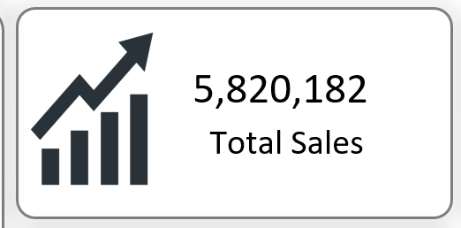

### 2. ****Average Sales per Transaction****

Computed the mean value of sales to understand average revenue generation per order, which helps identify spending behavior.

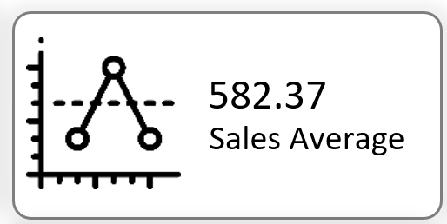

### 3. ****Total Number of Transactions****

Counted all individual entries to understand the volume of transactions handled by the retail business.

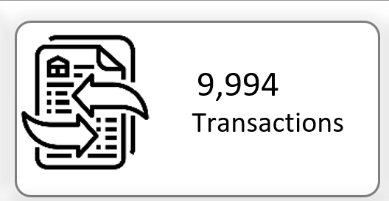

### 4. ****Total Quantity Sold****

Summed up the quantity column to find the total number of items sold across all orders.

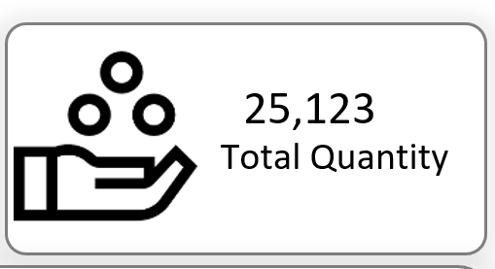

### 5. ****Ship Mode-wise Sales****

Analyzed sales figures segmented by shipping methods (e.g., Standard Class, First Class) to determine which shipping mode contributes most to revenue.

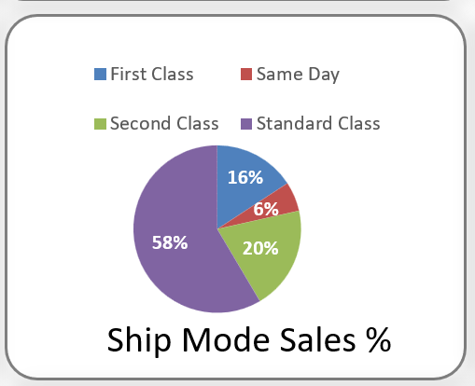

### 6. ****Zone-wise Transaction Count****

Grouped the data by geographic zones to observe how transactions are distributed regionally.

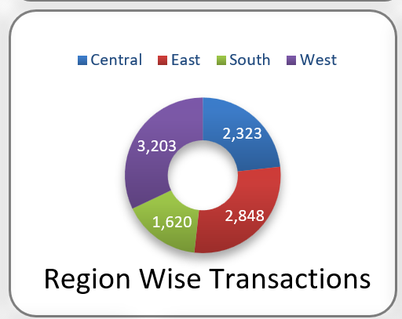

### 7. ****Month-wise Quantity Sold****

Converted order dates into monthly buckets and analyzed quantity sold to spot seasonal trends or sales peaks.

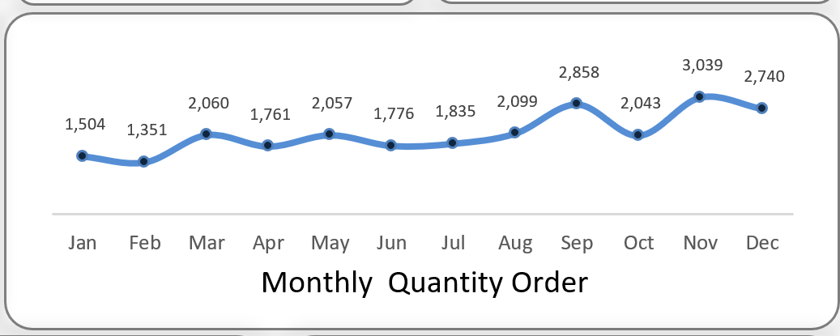

### 8. ****Top 5 Cities by Sales****

Ranked cities based on total sales to identify high-performing urban markets.

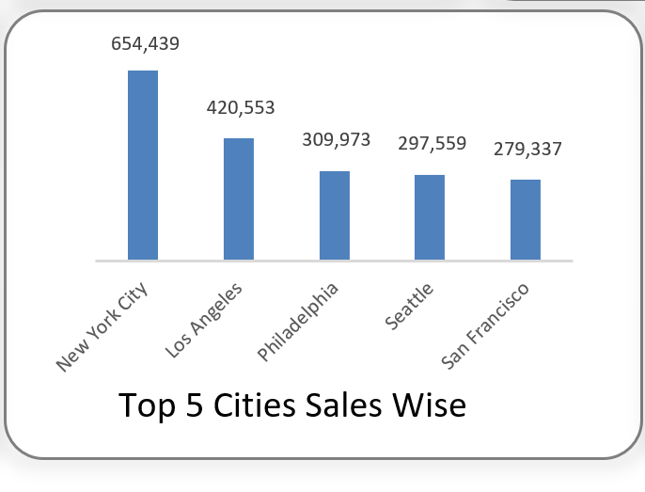

### 9. ****Category-wise Transaction Count****

Evaluated the number of transactions per product category (e.g., Furniture, Office Supplies, Technology) to see which category is most popular.

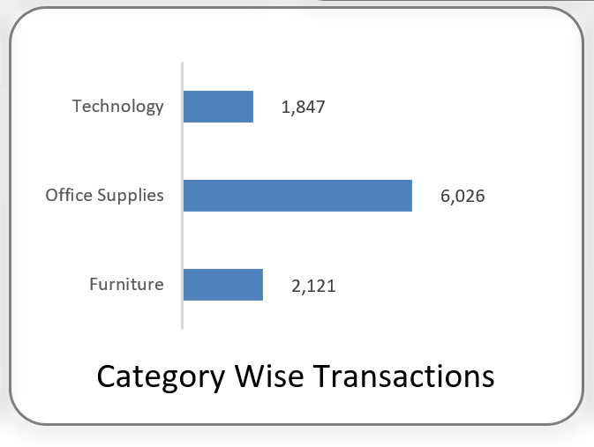

### 10. ****Consumer Type-wise Quantity Ordered****

Segmented data by customer types (e.g., Consumer, Corporate, Home Office) to analyze which group buys the most products.

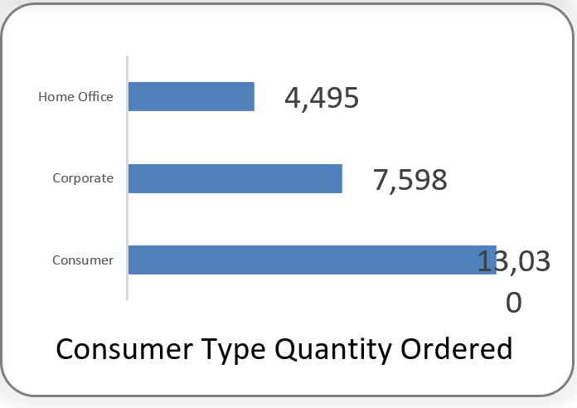

### 11. ****State-wise Total Sales****

Used a map visualization to represent how sales are distributed geographically across different states, helping to identify regional strengths and gaps.

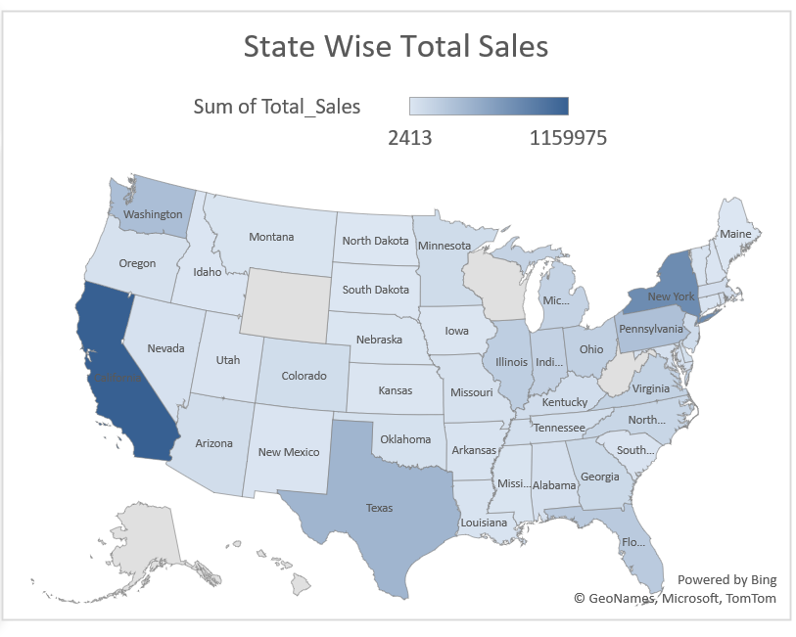

# 5. Conclusion

This project provided valuable insights into retail sales using Excel for data cleaning, analysis, and dashboard creation. Key metrics like total sales, quantity sold, and regional performance were explored. The interactive dashboard enables dynamic, user-friendly analysis, enhancing decision-making. Overall, the project strengthened my skills in data visualization and business analytics using Excel.

**# MY DASHBOARD**

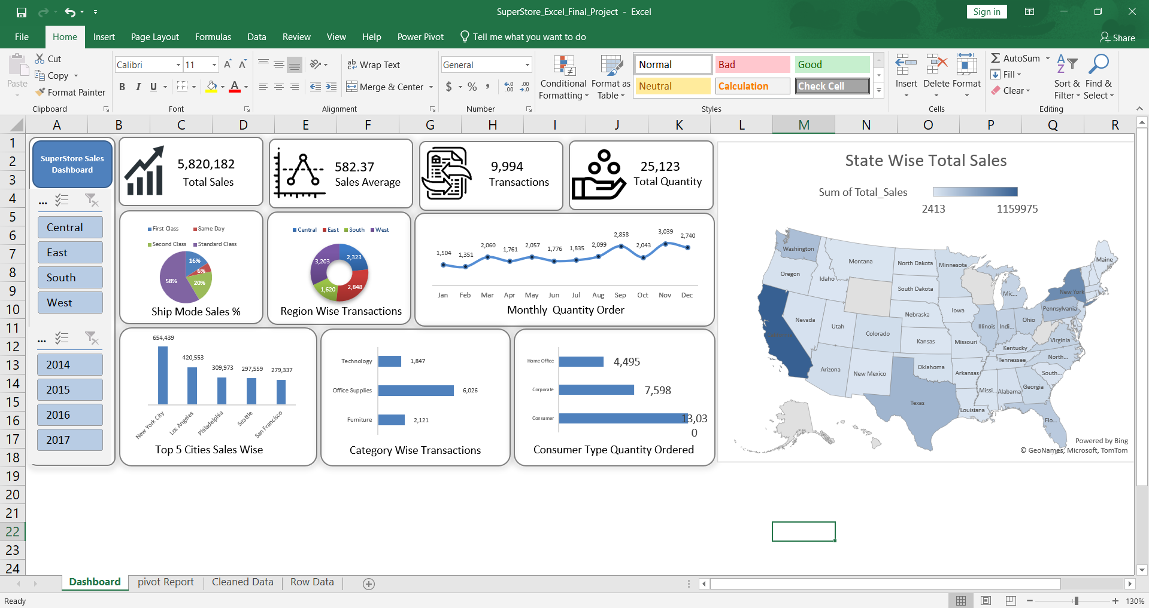

**MY GITHUB PROFILE** - <https://github.com/DeepakCdry/Excel-Data-Visualization>

**DATA SET LINK –**

[**https://catalog.data.gov/dataset/**](https://catalog.data.gov/dataset/)

# 6. Future Scope

This project lays the foundation for more advanced analytics and business intelligence solutions. In the future, it can be extended in the following ways:

* **Automation**: Implement Power Query or VBA scripts to automate data refresh and reporting.
* **Advanced Forecasting**: Integrate Excel forecasting tools or Python-based models to predict future sales trends.
* **Cloud Integration**: Publish the dashboard using platforms like Power BI or SharePoint for real-time access and collaboration.
* **Cross-Platform Analysis**: Combine this dataset with other business data such as customer feedback or inventory for more comprehensive insights.
* **Machine Learning Integration**: Use machine learning models for tasks like customer segmentation, sales prediction, or trend detection.

THANK YOU